## Wrapper类型

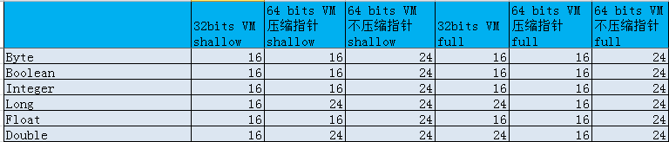

## 字符串相关

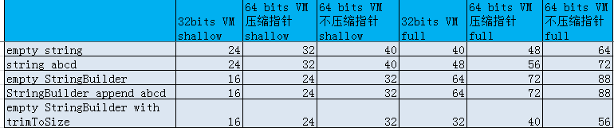

注意：

空字符串也是比较耗空间的。

我们来看一下64 bits VM 不压缩指针空字符的详细情况。

empty string

----------------------------------------------------------------

object class info : java.lang.String

object identityHashCode : 454535357

in parent info : root object

shallow size = 40

full size = 64

-----------shallow size detail.-----------------

headerType = NormalHeader size = 16

offset : 16 size = 8 private final char[] java.lang.String.value

offset : 24 size = 4 private final int java.lang.String.offset

offset : 28 size = 4 private final int java.lang.String.count

offset : 32 size = 4 private int java.lang.String.hash

padding size = 4

-----------end of shallow size detail.----------

object class info : char[]

object identityHashCode : 914783881

in parent info : private final char[] java.lang.String.value in parent.

shallow size = 24

full size = 24

-----------shallow size detail.-----------------

headerType = ArrayHeader size = 24

compType = char arrayLength = 0 size = ( 2 * 0 ) = 0

padding size = 0

-----------end of shallow size detail.----------

----------------------------------------------------------------